New patient interface improves
laser refractive cataract surgery

Alcon's latest LenSx® innovation, the SoftFit™ Patient Interface, incorporates a soft contact lens to contour the natural shape of the cornea and improve surgical performance. With less corneal distortion, laser accuracy and efficiency is increased. Nearly all cases result in a free-floating anterior capsulotomy, which is key in maintaining the integrity of the capsular bag for intraocular lens implantation.¹

"The new patient interface is a magnificent upgrade for Alcon's LenSx® laser platform," said Dr David Manning, of Hunter Cataract and Eye Centre. "It improves every aspect of the surgery. Laser docking is easier, the anterior segment images are better and because there are no corneal folds, laser delivery is faster and more precise."

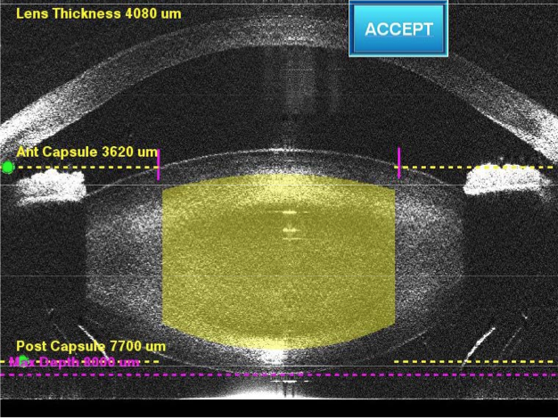
LenSx® high-resolution 3-D imaging allows the surgeon to create a precise surgical plan (lens fragmentation shaded yellow and shows clearance of anterior and posterior lens capsule).

With automation playing an increasingly important role in medical processes, Dr Manning sees the laser as the next evolution in cataract surgery. He uses the LenSx® laser for corneal incisions, anterior capsulotomy and pre-phaco lens fragmentation at the Hunter Valley Private Hospital and Charlestown Private Hospital.

"Results for manual cataract surgery, for the vast majority of patients are very good. What the LenSx® laser provides is greater predictability and the ability to match refractive outcomes to patient expectations," he said.

Published studies show intraocular lens positioning, a critical path that determines the residual refraction after surgery, is more accurate with LenSx® laser assisted surgery.^{2,3} Surgeons already use toric intraocular lenses to counteract surgically induced astigmatism and Dr Manning says the LenSx® laser is further tightening results.¹

The SoftFit™ Patient Interface widens the scope of who can have laser refractive cataract surgery. Multiple fracture patterns help shatter dense cataracts and a shorter procedure time reduces energy usage and trauma to the eye. Dr Manning says eyes with dense cataracts can take weeks to recover following manual surgery, but recover in days with LenSx®.¹ The intraocular pressure rise is also lower with the SoftFit™ Patient Interface (16mmHg above baseline), providing greater confidence in treating patients with elevated intraocular pressure.¹
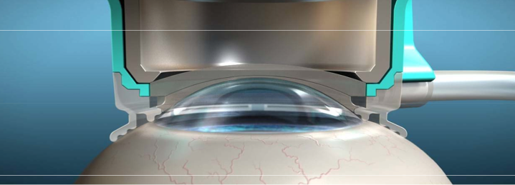
New LenSx® SoftFit™ Patient Interface incorporates a soft contact lens to contour the cornea, eliminating corneal compression in nearly all cases and improving surgical performance.

Dr Manning used the LenSx® laser with a 67 year-old patient with pseudoexfoliative glaucoma and phacodonesis (weakened zonular fibres). The laser produced a free-floating capsulotomy and pre-softened the cataract so it could be removed from the capsular bag without rotation. A multifocal intraocular lens was implanted and visual acuity was 6/6 and N5 on day 1.
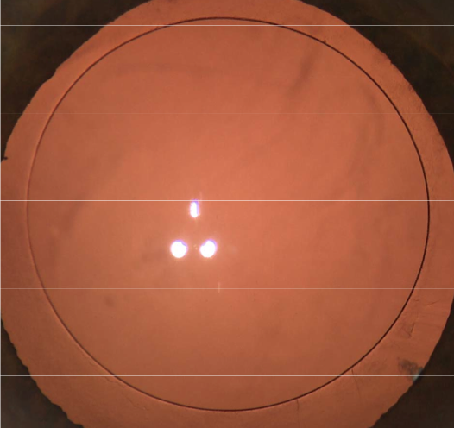
Dr Manning says without the LenSx® laser this type of case often leads to capsular rupture or lens dislocation, complicated surgery with vitrectomy, and implantation of an anterior chamber lens or a sutured posterior chamber lens, neither of which are multifocal. A large LenSx® series (n=1,300) performed at the Vision Eye Institute Chatswood reported capsular tears at a frequency of 0.62 per cent of eyes,⁴ which is lower than reported with manual surgery. ⁵

Pristine free-floating capsulotomy produced with LenSx® SoftFit™ Patient Interface and without the need to manually tear lens capsule.

LenSx® laser is not suitable for pediatric surgery, for patients with disease that precludes applanation of the cornea or conditions that prevent visualisation of the lens (eg. poorly dilating pupil, corneal opacity).

Alcon's LenSx® laser is approved by the FDA and TGA for corneal incisions, anterior capsulotomy and lens fragmentation. There are 373 LenSx® lasers installed worldwide, with over 120,000 procedures performed.⁶ The SoftFit™ Patient Interface is available at all LenSx® laser sites in Australia and New Zealand.

Company commissioned article by Jenny Saunders. LenSx is a registered trademark of Alcon Laboratories. Alcon Laboratories (Australia) Pty Ltd, 10/25 Frenchs Forest Road East, Frenchs Forest NSW 2086.

References
- Personal communication with Dr David Manning, 31 May 2013.
- Kránitz K, Takacs A, Miháltz K, Kovács I, Knorz MC, Nagy ZZ. Femtosecond laser capsulotomy and manual continuous curvilinear capsulorrhexis parameters and their effects on intraocular lens centration. Journal of Refractive Surgery 2011 27(8), 558–63. doi:10.3928/1081597X-20110623-03
- Kránitz K, Miháltz K, Sándor GL, Takacs A, Knorz MC, Nagy ZZ. Intraocular lens tilt and decentration measured by Scheimpflug camera following manual or femtosecond laser-created continuous circular capsulotomy. Journal of Refractive Surgery 2012, 28(4), 259–63. doi:10.3928/1081597X-20120309-01
- Roberts TV, Lawless M, Bali SJ, Hodge C, Sutton G. Surgical outcomes and safety of femtosecond laser cataract surgery : a prospective study of 1500 consecutive cases. Ophthalmol 2013 Feb;120(2):227-233. doi:10.1016/j.ophtha.2012.10.026.
- Lundström M, Behndig A, Kugelberg M, Montan P, Stenevi U, Thorburn W. Decreasing rate of capsule complications in cataract surgery: eight-year study of incidence, risk factors, and data validity by the Swedish National Cataract Register. J Cataract Refract Surg 2011 Oct;37(10):1762-1767. Epub 2011 Aug 6.
- Alcon data on file 2013.

